**Matkul : Pemrograman Perangkat Bergerak - TI – S1**

**NIM : A11.2019.11688**

**Nama : Bayu Prasetya Adji Sugiyarto**

**Pertemuan : 8**

**Word List SQL finished**

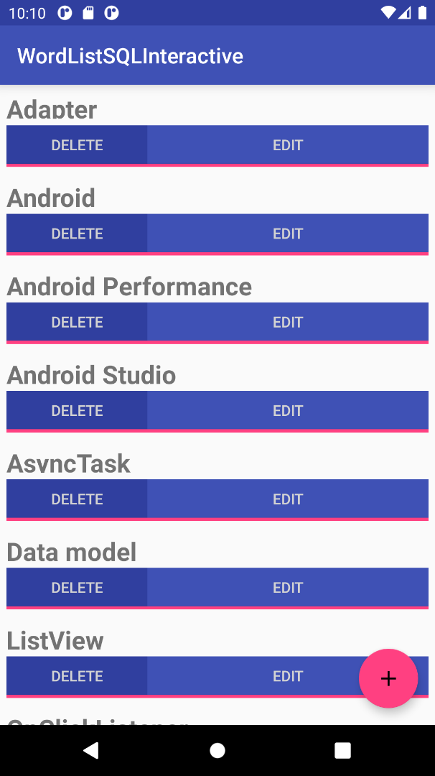

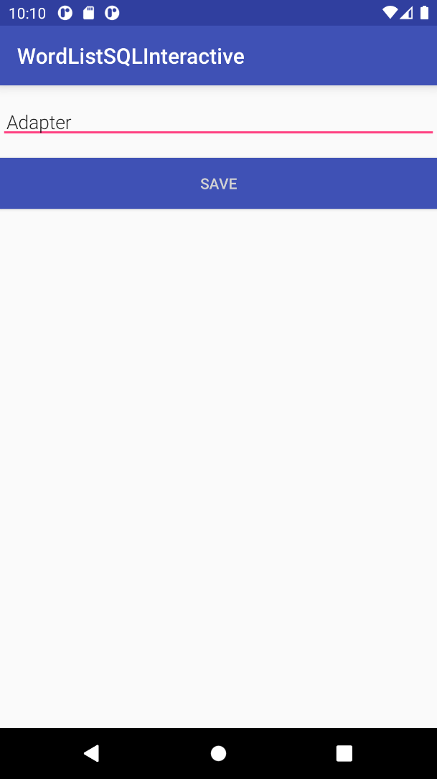

**String.xml**

*<?***xml version="1.0" encoding="utf-8"***?>*<**resources**>  
 <**string name="app_name"**>WordListSQLInteractive</**string**>  
 <**string name="hint_word"**>Word...</**string**>  
 <**string name="hint_definition"**>Definition...</**string**>  
 <**string name="button_save"**>Save</**string**>  
 <**string name="button_new"**>New</**string**>  
 <**string name="button_edit"**>Edit</**string**>  
 <**string name="button_delete"**>Delete</**string**>  
 <**string name="empty_not_saved"**>Word not saved because it is empty.</**string**>  
</**resources**>

**Layout**

**Activity_main.xml**

*<?***xml version="1.0" encoding="utf-8"***?>*<**android.support.design.widget.CoordinatorLayout  
 xmlns:android="http://schemas.android.com/apk/res/android"  
 android:layout_width="match_parent"  
 android:layout_height="match_parent"  
 android:orientation="vertical"**>  
  
 <**android.support.v7.widget.RecyclerView  
 android:id="@+id/recyclerview"  
 android:layout_width="match_parent"  
 android:layout_height="match_parent"**>  
 </**android.support.v7.widget.RecyclerView**>  
  
 <**android.support.design.widget.FloatingActionButton  
 android:id="@+id/fab"  
 android:layout_width="wrap_content"  
 android:layout_height="wrap_content"  
 android:layout_gravity="bottom|end"  
 android:layout_margin="16dp"  
 android:clickable="true"  
 android:src="@drawable/ic_add_24dp"** />  
  
</**android.support.design.widget.CoordinatorLayout**>

**Activity_edit_word.xml**

*<?***xml version="1.0" encoding="utf-8"***?>*<**LinearLayout xmlns:android="http://schemas.android.com/apk/res/android"  
 android:orientation="vertical" android:layout_width="match_parent"  
 android:layout_height="match_parent"**>  
  
 <**EditText  
 android:id="@+id/edit_word"  
 android:layout_width="match_parent"  
 android:layout_height="wrap_content"  
 android:fontFamily="sans-serif-light"  
 android:hint="@string/hint_word"  
 android:inputType="textAutoComplete"  
 android:padding="@dimen/small_padding"  
 android:layout_marginBottom="@dimen/big_padding"  
 android:layout_marginTop="@dimen/big_padding"  
 android:textSize="18sp"** />  
  
 <**Button  
 android:id="@+id/button_save"  
 android:layout_width="match_parent"  
 android:layout_height="wrap_content"  
 android:background="@color/colorPrimary"  
 android:onClick="returnReply"  
 android:text="@string/button_save"  
 android:textColor="@color/buttonLabel"** />  
  
</**LinearLayout**>

**Wordlist_item**

*<?***xml version="1.0" encoding="utf-8"***?>*<**LinearLayout xmlns:android="http://schemas.android.com/apk/res/android"  
 android:layout_width="match_parent"  
 android:layout_height="wrap_content"  
 android:orientation="vertical"  
 android:padding="6dp"**>  
  
 <**TextView  
 android:id="@+id/word"  
 android:layout_width="match_parent"  
 style="@style/word_title"** />  
  
 <**LinearLayout  
 android:layout_width="match_parent"  
 android:layout_height="wrap_content"  
 android:orientation="horizontal"**>  
  
 <**Button  
 android:id="@+id/delete_button"  
 android:layout_width="match_parent"  
 android:layout_height="@dimen/button_height"  
 android:layout_weight="2"  
 android:background="@color/colorPrimaryDark"  
 android:text="@string/button_delete"  
 android:textColor="@color/buttonLabel"**/>  
  
 <**Button  
 android:id="@+id/edit_button"  
 android:layout_width="match_parent"  
 android:layout_height="@dimen/button_height"  
 android:layout_weight="1"  
 android:background="@color/colorPrimary"  
 android:text="@string/button_edit"  
 android:textColor="@color/buttonLabel"**/>  
  
 </**LinearLayout**>  
  
 <**Button  
 android:layout_width="match_parent"  
 android:layout_height="@dimen/divider_height"  
 android:background="@color/colorAccent"** />  
  
</**LinearLayout**>

**Java**

**Mainactivity.java**

**package** com.android.example.wordlistsql;  
  
**import** android.content.Intent;  
**import** android.os.Bundle;  
**import** android.support.design.widget.FloatingActionButton;  
**import** android.support.v7.app.AppCompatActivity;  
**import** android.support.v7.widget.LinearLayoutManager;  
**import** android.support.v7.widget.RecyclerView;  
**import** android.text.TextUtils;  
**import** android.view.View;  
**import** android.widget.Toast;  
  
  
**public class** MainActivity **extends** AppCompatActivity {  
  
 **private static final** String ***TAG*** = MainActivity.**class**.getSimpleName();  
  
 **public static final int *WORD_EDIT*** = 1;  
 **public static final int *WORD_ADD*** = -1;  
  
 **private** WordListOpenHelper **mDB**;  
 **private** RecyclerView **mRecyclerView**;  
 **private** WordListAdapter **mAdapter**;  
 **private int mLastPosition**;  
  
 @Override  
 **public void** onCreate(Bundle savedInstanceState) {  
 **super**.onCreate(savedInstanceState);  
 setContentView(R.layout.***activity_main***);  
  
 **mDB** = **new** WordListOpenHelper(**this**);  
  
 *// Create recycler view.* **mRecyclerView** = (RecyclerView) findViewById(R.id.***recyclerview***);  
 *// Create an mAdapter and supply the data to be displayed.* **mAdapter** = **new** WordListAdapter(**this**, */* mDB.getAllEntries(),*/* **mDB**);  
 *// Connect the mAdapter with the recycler view.* **mRecyclerView**.setAdapter(**mAdapter**);  
 *// Give the recycler view a default layout manager.* **mRecyclerView**.setLayoutManager(**new** LinearLayoutManager(**this**));  
  
 *// Add a floating action click handler for creating new entries.* FloatingActionButton fab = (FloatingActionButton) findViewById(R.id.***fab***);  
 fab.setOnClickListener(**new** View.OnClickListener() {  
 @Override  
 **public void** onClick(View view) {  
 *// Starts empty edit activity.* Intent intent = **new** Intent(getBaseContext(), EditWordActivity.**class**);  
 startActivityForResult(intent, ***WORD_EDIT***);  
 }  
 });  
 }  
  
 **public void** onActivityResult(**int** requestCode, **int** resultCode, Intent data) {  
 **super**.onActivityResult(requestCode, resultCode, data);  
  
 **if** (requestCode == ***WORD_EDIT***) {  
 **if** (resultCode == ***RESULT_OK***) {  
 String word = data.getStringExtra(EditWordActivity.***EXTRA_REPLY***);  
  
 *// Update the database.* **if** (!TextUtils.*isEmpty*(word)) {  
 **int** id = data.getIntExtra(WordListAdapter.***EXTRA_ID***, -99);  
  
 **if** (id == ***WORD_ADD***) {  
 **mDB**.insert(word);  
 } **else if** (id >= 0) {  
 **mDB**.update(id, word);  
 }  
 *// Update the UI.* **mAdapter**.notifyDataSetChanged();  
 } **else** {  
 Toast.*makeText*(  
 getApplicationContext(),  
 R.string.***empty_not_saved***,  
 Toast.***LENGTH_LONG***).show();  
 }  
 }  
 }  
 }  
}

**EditWordActivity.java**

**package** com.android.example.wordlistsql;  
  
**import** android.content.Intent;  
**import** android.os.Bundle;  
**import** android.support.v7.app.AppCompatActivity;  
**import** android.view.View;  
**import** android.widget.EditText;  
  
**public class** EditWordActivity **extends** AppCompatActivity {  
  
 **private static final** String ***TAG*** = EditWordActivity.**class**.getSimpleName();  
  
 **private static final int *NO_ID*** = -99;  
 **private static final** String ***NO_WORD*** = **""**;  
  
 **private** EditText **mEditWordView**;  
  
 *// Unique tag for the intent reply.* **public static final** String ***EXTRA_REPLY*** = **"com.example.android.wordlistsql.REPLY"**;  
  
 **int mId** = MainActivity.***WORD_ADD***;  
  
 @Override  
 **public void** onCreate(Bundle savedInstanceState) {  
 **super**.onCreate(savedInstanceState);  
 setContentView(R.layout.***activity_edit_word***);  
  
 **mEditWordView** = (EditText) findViewById(R.id.***edit_word***);  
  
 *// Get data sent from calling activity.* Bundle extras = getIntent().getExtras();  
  
 *// If we are passed content, fill it in for the user to edit.* **if** (extras != **null**) {  
 **int** id = extras.getInt(WordListAdapter.***EXTRA_ID***, ***NO_ID***);  
 String word = extras.getString(WordListAdapter.***EXTRA_WORD***, ***NO_WORD***);  
 **if** ((id != ***NO_ID***) && (word != ***NO_WORD***)) {  
 **mId** = id;  
 **mEditWordView**.setText(word);  
 }  
 } *// Otherwise, start with empty fields.* }  
   
 **public void** returnReply(View view) {  
 String word = ((EditText) findViewById(R.id.***edit_word***)).getText().toString();  
  
 Intent replyIntent = **new** Intent();  
 replyIntent.putExtra(***EXTRA_REPLY***, word);  
 replyIntent.putExtra(WordListAdapter.***EXTRA_ID***, **mId**);  
 setResult(***RESULT_OK***, replyIntent);  
 finish();  
 }  
}

**WordItem.java**

**package** com.android.example.wordlistsql;  
  
  
**public class** WordItem {  
  
 **private int mId**;  
 **private** String **mWord**;  
  
 **public** WordItem() {}  
  
 **public int** getId() {  
 **return this**.**mId**;  
 }  
  
 **public** String getWord() {  
 **return this**.**mWord**;  
 }  
  
 **public void** setId(**int** id) {  
 **this**.**mId** = id;  
 }  
  
 **public void** setWord(String word) {  
 **this**.**mWord** = word;  
 }  
}

**WordListAdapter.java**

**package** com.android.example.wordlistsql;  
  
**import** android.app.Activity;  
**import** android.content.Context;  
**import** android.content.Intent;  
**import** android.support.v7.widget.RecyclerView;  
**import** android.util.Log;  
**import** android.view.LayoutInflater;  
**import** android.view.View;  
**import** android.view.ViewGroup;  
**import** android.widget.Button;  
**import** android.widget.TextView;  
  
  
**public class** WordListAdapter **extends** RecyclerView.Adapter<WordListAdapter.WordViewHolder> {  
  
 **class** WordViewHolder **extends** RecyclerView.ViewHolder {  
 **public final** TextView **wordItemView**;  
 Button **delete_button**;  
 Button **edit_button**;  
  
 **public** WordViewHolder(View itemView) {  
 **super**(itemView);  
 **wordItemView** = (TextView) itemView.findViewById(R.id.***word***);  
 **delete_button** = (Button)itemView.findViewById(R.id.***delete_button***);  
 **edit_button** = (Button)itemView.findViewById(R.id.***edit_button***);  
 }  
 }  
  
 **private static final** String ***TAG*** = WordListAdapter.**class**.getSimpleName();  
  
 **public static final** String ***EXTRA_ID*** = **"ID"**;  
 **public static final** String ***EXTRA_WORD*** = **"WORD"**;  
 **public static final** String ***EXTRA_POSITION*** = **"POSITION"**;  
  
 **private final** LayoutInflater **mInflater**;  
 WordListOpenHelper **mDB**;  
 Context **mContext**;  
  
 **public** WordListAdapter(Context context, WordListOpenHelper db) {  
 **mInflater** = LayoutInflater.*from*(context);  
 **mContext** = context;  
 **mDB** = db;  
 }  
  
 @Override  
 **public** WordViewHolder onCreateViewHolder(ViewGroup parent, **int** viewType) {  
 View itemView = **mInflater**.inflate(R.layout.***wordlist_item***, parent, **false**);  
 **return new** WordViewHolder(itemView);  
 }  
  
 @Override  
 **public void** onBindViewHolder(WordViewHolder holder, **int** position) {  
 WordItem current = **mDB**.query(position);  
 holder.**wordItemView**.setText(current.getWord());  
 *// Keep a reference to the view holder for the click listener* **final** WordViewHolder h = holder; *// needs to be final for use in callback  
 // Attach a click listener to the DELETE button.* holder.**delete_button**.setOnClickListener(**new** MyButtonOnClickListener(  
 current.getId(), **null**) {  
  
  
 @Override  
 **public void** onClick(View v ) {  
 *// You have to get the position like this, you can't hold a reference* Log.*d* (***TAG*** + **"onClick"**, **"VHPos "** + h.getAdapterPosition() + **" ID "** + **id**);  
 **int** deleted = **mDB**.delete(**id**);  
 **if** (deleted >= 0)  
 notifyItemRemoved(h.getAdapterPosition());  
 }  
 });  
  
 *// Attach a click listener to the EDIT button.* holder.**edit_button**.setOnClickListener(**new** MyButtonOnClickListener(  
 current.getId(), current.getWord()) {  
  
 @Override  
 **public void** onClick(View v) {  
 Intent intent = **new** Intent(**mContext**, EditWordActivity.**class**);  
  
 intent.putExtra(***EXTRA_ID***, **id**);  
 intent.putExtra(***EXTRA_POSITION***, h.getAdapterPosition());  
 intent.putExtra(***EXTRA_WORD***, **word**);  
  
 *// Start an empty edit activity.* ((Activity) **mContext**).startActivityForResult(intent, MainActivity.***WORD_EDIT***);  
 }  
 });  
 }  
  
 @Override  
 **public int** getItemCount() {  
 **return** (**int**) **mDB**.count();  
 }  
}

**WordListOpenHelper.java**

**package** com.android.example.wordlistsql;  
  
**import** android.content.ContentValues;  
**import** android.content.Context;  
**import** android.database.Cursor;  
**import** android.database.DatabaseUtils;  
**import** android.database.sqlite.SQLiteDatabase;  
**import** android.database.sqlite.SQLiteOpenHelper;  
**import** android.util.Log;  
  
**public class** WordListOpenHelper **extends** SQLiteOpenHelper {  
  
 **private static final** String ***TAG*** = WordListOpenHelper.**class**.getSimpleName();  
  
 /  
   
 **private static final int *DATABASE_VERSION*** = 1;  
 **private static final** String ***WORD_LIST_TABLE*** = **"word_entries"**;  
 **private static final** String ***DATABASE_NAME*** = **"wordlist"**;  
  
 *// Column names...* **public static final** String ***KEY_ID*** = **"_id"**;  
 **public static final** String ***KEY_WORD*** = **"word"**;  
  
 *// ... and a string array of columns.* **private static final** String[] ***COLUMNS*** =  
 {***KEY_ID***, ***KEY_WORD***};  
  
 *// Build the SQL query that creates the table.* **private static final** String ***WORD_LIST_TABLE_CREATE*** =  
 **"CREATE TABLE "** + ***WORD_LIST_TABLE*** + **" ("** +  
 ***KEY_ID*** + **" INTEGER PRIMARY KEY, "** + *// will auto-increment if no value passed* ***KEY_WORD*** + **" TEXT );"**;  
  
 **private** SQLiteDatabase **mWritableDB**;  
 **private** SQLiteDatabase **mReadableDB**;  
  
 **public** WordListOpenHelper(Context context) {  
 **super**(context, ***DATABASE_NAME***, **null**, ***DATABASE_VERSION***);  
 Log.*d*(***TAG***, **"Construct WordListOpenHelper"**);  
 }  
  
 @Override  
 **public void** onCreate(SQLiteDatabase db) {  
 db.execSQL(***WORD_LIST_TABLE_CREATE***);  
 fillDatabaseWithData(db);  
  
 }  
   
 **public void** fillDatabaseWithData(SQLiteDatabase db) {  
  
 String[] words = {**"Android"**, **"Adapter"**, **"ListView"**, **"AsyncTask"**, **"Android Studio"**,  
 **"SQLiteDatabase"**, **"SQLOpenHelper"**, **"Data model"**, **"ViewHolder"**,  
 **"Android Performance"**, **"OnClickListener"**};  
  
 *// Create a container for the data.* ContentValues values = **new** ContentValues();  
  
 **for** (**int** i=0; i < words.**length**;i++) {  
 *// Put column/value pairs into the container. put() overwrites existing values.* values.put(***KEY_WORD***, words[i]);  
 db.insert(***WORD_LIST_TABLE***, **null**, values);  
 }  
 }  
   
 **public** WordItem query(**int** position) {  
 String query = **"SELECT * FROM "** + ***WORD_LIST_TABLE*** +  
 **" ORDER BY "** + ***KEY_WORD*** + **" ASC "** +  
 **"LIMIT "** + position + **",1"**;  
  
 Cursor cursor = **null**;  
 WordItem entry = **new** WordItem();  
  
 **try** {  
 **if** (**mReadableDB** == **null**) {**mReadableDB** = getReadableDatabase();}  
 cursor = **mReadableDB**.rawQuery(query, **null**);  
 cursor.moveToFirst();  
 entry.setId(cursor.getInt(cursor.getColumnIndex(***KEY_ID***)));  
 entry.setWord(cursor.getString(cursor.getColumnIndex(***KEY_WORD***)));  
 } **catch** (Exception e) {  
 Log.*d*(***TAG***, **"QUERY EXCEPTION! "** + e.getMessage());  
 } **finally** {  
 *// Must close cursor and db now that we are done with it.* cursor.close();  
 **return** entry;  
 }  
 }  
  
  
 **public long** count() {  
 **if** (**mReadableDB** == **null**) {**mReadableDB** = getReadableDatabase();}  
 **return** DatabaseUtils.*queryNumEntries*(**mReadableDB**, ***WORD_LIST_TABLE***);  
 }  
  
  
 **public long** insert(String word) {  
 **long** newId = 0;  
 ContentValues values = **new** ContentValues();  
 values.put(***KEY_WORD***, word);  
 **try** {  
 **if** (**mWritableDB** == **null**) {**mWritableDB** = getWritableDatabase();}  
 newId = **mWritableDB**.insert(***WORD_LIST_TABLE***, **null**, values);  
 } **catch** (Exception e) {  
 Log.*d*(***TAG***, **"INSERT EXCEPTION! "** + e.getMessage());  
 }  
 **return** newId;  
 }  
  
  
 **public int** update(**int** id, String word) {  
 **int** mNumberOfRowsUpdated = -1;  
 **try** {  
 **if** (**mWritableDB** == **null**) {**mWritableDB** = getWritableDatabase();}  
 ContentValues values = **new** ContentValues();  
 values.put(***KEY_WORD***, word);  
  
 mNumberOfRowsUpdated = **mWritableDB**.update(***WORD_LIST_TABLE***, *//table to change* values, *// new values to insert* ***KEY_ID*** + **" = ?"**, *// selection criteria for row (in this case, the _id column)* **new** String[]{String.*valueOf*(id)}); *//selection args; the actual value of the id* } **catch** (Exception e) {  
 Log.*d* (***TAG***, **"UPDATE EXCEPTION! "** + e.getMessage());  
 }  
 **return** mNumberOfRowsUpdated;  
 }  
  
 **public int** delete(**int** id) {  
 **int** deleted = 0;  
 **try** {  
 **if** (**mWritableDB** == **null**) {**mWritableDB** = getWritableDatabase();}  
 deleted = **mWritableDB**.delete(***WORD_LIST_TABLE***, *//table name* ***KEY_ID*** + **" = ? "**, **new** String[]{String.*valueOf*(id)});  
 } **catch** (Exception e) {  
 Log.*d* (***TAG***, **"DELETE EXCEPTION! "** + e.getMessage()); }  
 **return** deleted;  
 }  
  
  
 @Override  
 **public void** onUpgrade(SQLiteDatabase db, **int** oldVersion, **int** newVersion) {  
 Log.*w*(WordListOpenHelper.**class**.getName(),  
 **"Upgrading database from version "** + oldVersion + **" to "** + newVersion + **", which will destroy all old data"**);  
 db.execSQL(**"DROP TABLE IF EXISTS "** + ***WORD_LIST_TABLE***);  
 onCreate(db);  
 }  
}

**Word List SQL Searchable**

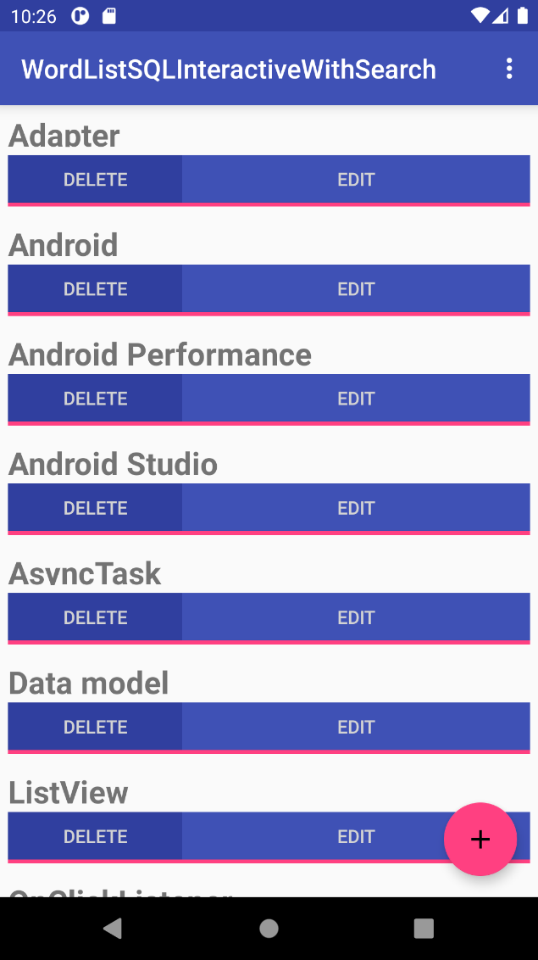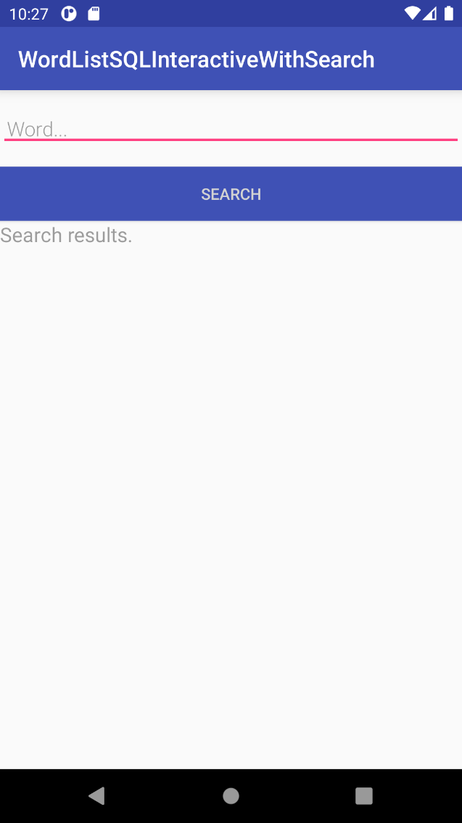

**String.xml**

*<?***xml version="1.0" encoding="utf-8"***?>*<**resources**>  
 <**string name="app_name"**>WordListSQLInteractiveWithSearch</**string**>  
 <**string name="hint_word"**>Word...</**string**>  
 <**string name="hint_definition"**>Definition...</**string**>  
 <**string name="button_save"**>Save</**string**>  
 <**string name="button_new"**>New</**string**>  
 <**string name="button_edit"**>Edit</**string**>  
 <**string name="button_delete"**>Delete</**string**>  
 <**string name="button_search"**>Search</**string**>  
 <**string name="search_results"**>Search results.</**string**>  
 <**string name="menu_search"**>Search...</**string**>  
 <**string name="empty_word_not_saved"**>Word not saved because it is empty.</**string**>  
 <**string name="no_result"**>No result.</**string**>  
</**resources**>

**Layout**

**Activity_main.xml**

*<?***xml version="1.0" encoding="utf-8"***?>*<**android.support.design.widget.CoordinatorLayout  
 xmlns:android="http://schemas.android.com/apk/res/android"  
 android:layout_width="match_parent"  
 android:layout_height="match_parent"  
 android:orientation="vertical"**>  
  
 <**android.support.v7.widget.RecyclerView  
 android:id="@+id/recyclerview"  
 android:layout_width="match_parent"  
 android:layout_height="match_parent"**>  
 </**android.support.v7.widget.RecyclerView**>  
  
 <**android.support.design.widget.FloatingActionButton  
 android:id="@+id/fab"  
 android:layout_width="wrap_content"  
 android:layout_height="wrap_content"  
 android:layout_gravity="bottom|end"  
 android:layout_margin="16dp"  
 android:clickable="true"  
 android:src="@drawable/ic_add_24dp"** />  
  
</**android.support.design.widget.CoordinatorLayout**>

**Activity_edit_word.xml**

*<?***xml version="1.0" encoding="utf-8"***?>*<**LinearLayout xmlns:android="http://schemas.android.com/apk/res/android"  
 android:orientation="vertical" android:layout_width="match_parent"  
 android:layout_height="match_parent"**>  
  
 <**EditText  
 android:id="@+id/edit_word"  
 android:layout_width="match_parent"  
 android:layout_height="wrap_content"  
 android:fontFamily="sans-serif-light"  
 android:hint="@string/hint_word"  
 android:inputType="textAutoComplete"  
 android:padding="@dimen/small_padding"  
 android:layout_marginBottom="@dimen/big_padding"  
 android:layout_marginTop="@dimen/big_padding"  
 android:textSize="18sp"** />  
  
 <**Button  
 android:id="@+id/button_save"  
 android:layout_width="match_parent"  
 android:layout_height="wrap_content"  
 android:background="@color/colorPrimary"  
 android:onClick="returnReply"  
 android:text="@string/button_save"  
 android:textColor="@color/buttonLabel"** />  
  
</**LinearLayout**>

**Activity_search.xml**

*<?***xml version="1.0" encoding="utf-8"***?>*<**LinearLayout xmlns:android="http://schemas.android.com/apk/res/android"  
 android:orientation="vertical" android:layout_width="match_parent"  
 android:layout_height="match_parent"**>  
  
 <**EditText  
 android:id="@+id/search_word"  
 android:layout_width="match_parent"  
 android:layout_height="wrap_content"  
 android:fontFamily="sans-serif-light"  
 android:hint="@string/hint_word"  
 android:inputType="textAutoComplete"  
 android:padding="@dimen/small_padding"  
 android:layout_marginBottom="@dimen/big_padding"  
 android:layout_marginTop="@dimen/big_padding"  
 android:textSize="18sp"** />  
  
 <**Button  
 android:id="@+id/button_search"  
 android:layout_width="match_parent"  
 android:layout_height="wrap_content"  
 android:background="@color/colorPrimary"  
 android:onClick="showResult"  
 android:text="@string/button_search"  
 android:textColor="@color/buttonLabel"** />  
  
 <**TextView  
 android:id="@+id/search_result"  
 android:layout_width="match_parent"  
 android:layout_height="300dp"  
 android:textSize="18sp"  
 android:hint="@string/search_results"**/>  
  
</**LinearLayout**>

**Wordlist_item.xml**

*<?***xml version="1.0" encoding="utf-8"***?>*<**LinearLayout xmlns:android="http://schemas.android.com/apk/res/android"  
 android:layout_width="match_parent"  
 android:layout_height="wrap_content"  
 android:orientation="vertical"  
 android:padding="6dp"**>  
  
 <**TextView  
 android:id="@+id/word"  
 android:layout_width="match_parent"  
 style="@style/word_title"** />  
  
 <**LinearLayout  
 android:layout_width="match_parent"  
 android:layout_height="wrap_content"  
 android:orientation="horizontal"**>  
  
 <**Button  
 android:id="@+id/delete_button"  
 android:layout_width="match_parent"  
 android:layout_height="@dimen/button_height"  
 android:layout_weight="2"  
 android:background="@color/colorPrimaryDark"  
 android:text="@string/button_delete"  
 android:textColor="@color/buttonLabel"**/>  
  
 <**Button  
 android:id="@+id/edit_button"  
 android:layout_width="match_parent"  
 android:layout_height="@dimen/button_height"  
 android:layout_weight="1"  
 android:background="@color/colorPrimary"  
 android:text="@string/button_edit"  
 android:textColor="@color/buttonLabel"**/>  
  
 </**LinearLayout**>  
  
 <**Button  
 android:layout_width="match_parent"  
 android:layout_height="@dimen/divider_height"  
 android:background="@color/colorAccent"** />  
  
</**LinearLayout**>

**Mainactivity**

**package** com.android.example.wordlistsqlsearchable;  
  
**import** android.content.Intent;  
**import** android.os.Bundle;  
**import** android.support.design.widget.FloatingActionButton;  
**import** android.support.v7.app.AppCompatActivity;  
**import** android.support.v7.widget.LinearLayoutManager;  
**import** android.support.v7.widget.RecyclerView;  
**import** android.text.TextUtils;  
**import** android.view.Menu;  
**import** android.view.MenuItem;  
**import** android.view.View;  
**import** android.widget.Toast;  
  
**public class** MainActivity **extends** AppCompatActivity {  
  
 **private static final** String ***TAG*** = MainActivity.**class**.getSimpleName();  
  
 **public static final int *WORD_EDIT*** = 1;  
 **public static final int *WORD_ADD*** = -1;  
  
 **private** WordListOpenHelper **mDB**;  
 **private** RecyclerView **mRecyclerView**;  
 **private** WordListAdapter **mAdapter**;  
  
 @Override  
 **public void** onCreate(Bundle savedInstanceState) {  
 **super**.onCreate(savedInstanceState);  
 setContentView(R.layout.***activity_main***);  
  
 **mDB** = **new** WordListOpenHelper(**this**);  
  
 *// Create recycler view.* **mRecyclerView** = (RecyclerView) findViewById(R.id.***recyclerview***);  
 *// Create an mAdapter and supply the data to be displayed.* **mAdapter** = **new** WordListAdapter(**this**, */* mDB.getAllEntries(),*/* **mDB**);  
 *// Connect the mAdapter with the recycler view.* **mRecyclerView**.setAdapter(**mAdapter**);  
 *// Give the recycler view a default layout manager.* **mRecyclerView**.setLayoutManager(**new** LinearLayoutManager(**this**));  
  
 *// Add a floating action click handler for creating new entries.* FloatingActionButton fab = (FloatingActionButton) findViewById(R.id.***fab***);  
 fab.setOnClickListener(**new** View.OnClickListener() {  
 @Override  
 **public void** onClick(View view) {  
 *// Starts empty edit activity.* Intent intent = **new** Intent(getBaseContext(), EditWordActivity.**class**);  
 startActivityForResult(intent, ***WORD_EDIT***);  
 }  
 });  
 }  
  
 @Override  
 **public boolean** onCreateOptionsMenu(Menu menu) {  
 getMenuInflater().inflate(R.menu.***menu_main***, menu);  
 **return true**;  
 }  
  
 @Override  
 **public boolean** onOptionsItemSelected(MenuItem item) {  
 **switch** (item.getItemId()) {  
 **case** R.id.***action_search***:  
 *// Starts search activity.* Intent intent = **new** Intent(getBaseContext(), com.android.example.wordlistsqlsearchable.SearchActivity.**class**);  
 startActivity(intent);  
 **return true**;  
 }  
 **return super**.onOptionsItemSelected(item);  
 }  
  
 **public void** onActivityResult(**int** requestCode, **int** resultCode, Intent data) {  
 **super**.onActivityResult(requestCode, resultCode, data);  
  
 **if** (requestCode == ***WORD_EDIT***) {  
 **if** (resultCode == ***RESULT_OK***) {  
 String word = data.getStringExtra(EditWordActivity.***EXTRA_REPLY***);  
  
 *// Update the database.* **if** (!TextUtils.*isEmpty*(word)) {  
 **int** id = data.getIntExtra(WordListAdapter.***EXTRA_ID***, -99);  
  
 **if** (id == ***WORD_ADD***) {  
 **mDB**.insert(word);  
 } **else if** (id >= 0) {  
 **mDB**.update(id, word);  
 }  
 *// Update the UI.* **mAdapter**.notifyDataSetChanged();  
 } **else** {  
 Toast.*makeText*(  
 getApplicationContext(),  
 R.string.***empty_word_not_saved***,  
 Toast.***LENGTH_LONG***).show();  
 }  
 }  
 }  
 }  
}

**EditWordActivity.java**

**package** com.android.example.wordlistsqlsearchable;  
  
**import** android.content.Intent;  
**import** android.os.Bundle;  
**import** android.support.v7.app.AppCompatActivity;  
**import** android.view.View;  
**import** android.widget.EditText;  
  
**public class** EditWordActivity **extends** AppCompatActivity {  
  
 **private static final** String ***TAG*** = EditWordActivity.**class**.getSimpleName();  
  
 **private static final int *NO_ID*** = -99;  
 **private static final** String ***NO_WORD*** = **""**;  
  
 **private** EditText **mEditWordView**;  
  
 *// Unique tag for the intent reply.* **public static final** String ***EXTRA_REPLY*** = **"com.example.android.wordlistsql.REPLY"**;  
  
 **int mId** = MainActivity.***WORD_ADD***;  
  
 @Override  
 **public void** onCreate(Bundle savedInstanceState) {  
 **super**.onCreate(savedInstanceState);  
 setContentView(R.layout.***activity_edit_word***);  
  
 **mEditWordView** = (EditText) findViewById(R.id.***edit_word***);  
  
 *// Get data sent from calling activity.* Bundle extras = getIntent().getExtras();  
  
 *// If we are passed content, fill it in for the user to edit.* **if** (extras != **null**) {  
 **int** id = extras.getInt(WordListAdapter.***EXTRA_ID***, ***NO_ID***);  
 String word = extras.getString(WordListAdapter.***EXTRA_WORD***, ***NO_WORD***);  
 **if** (id != ***NO_ID*** && word != ***NO_WORD***) {  
 **mId** = id;  
 **mEditWordView**.setText(word);  
 }  
 } *// Otherwise, start with empty fields.* }  
  
 **public void** returnReply(View view) {  
 String word = ((EditText) findViewById(R.id.***edit_word***)).getText().toString();  
  
 Intent replyIntent = **new** Intent();  
 replyIntent.putExtra(***EXTRA_REPLY***, word);  
 replyIntent.putExtra(WordListAdapter.***EXTRA_ID***, **mId**);  
 setResult(***RESULT_OK***, replyIntent);  
 finish();  
 }  
}

**MyButtonOnClickListener.java**

**package** com.android.example.wordlistsqlsearchable;  
  
**import** android.view.View;  
  
  
**public class** MyButtonOnClickListener **implements** View.OnClickListener {  
 **private static final** String ***TAG*** = View.OnClickListener.**class**.getSimpleName();  
  
 **int id**;  
 String **word**;  
  
 **public** MyButtonOnClickListener(**int** id, String word) {  
 **this**.**id** = id;  
 **this**.**word** = word;  
 }  
  
 **public void** onClick(View v) {  
 *// Implemented in WordListAdapter* }  
  
}

**SearchActiviy.java**

**package** com.android.example.wordlistsqlsearchable;  
  
**import** android.database.Cursor;  
**import** android.os.Bundle;  
**import** android.support.v7.app.AppCompatActivity;  
**import** android.view.View;  
**import** android.widget.EditText;  
**import** android.widget.TextView;  
  
  
**public class** SearchActivity **extends** AppCompatActivity {  
  
 **private static final** String ***TAG*** = EditWordActivity.**class**.getSimpleName();  
  
 **private** WordListOpenHelper **mDB**;  
  
 **private** EditText **mEditWordView**;  
 **private** TextView **mTextView**;  
  
 @Override  
 **public void** onCreate(Bundle savedInstanceState) {  
 **super**.onCreate(savedInstanceState);  
 setContentView(R.layout.***activity_search***);  
  
 **mDB** = **new** WordListOpenHelper(**this**);  
  
 **mEditWordView** = ((EditText) findViewById(R.id.***search_word***));  
 **mTextView** = ((TextView) findViewById(R.id.***search_result***));  
 }  
  
 *// Click handler for Search button.* **public void** showResult(View view) {  
 String word = **mEditWordView**.getText().toString();  
 **mTextView**.setText(**"Result for "** + word + **":\n\n"**);  
  
 *// Search for the word in the database.* Cursor cursor = **mDB**.search(word);  
 *// You must move the cursor to the first item.* cursor.moveToFirst();  
 *// Only process a non-null cursor with rows.* **if** (cursor != **null** & cursor.getCount() > 0) {  
 **int** index;  
 String result;  
 *// Iterate over the cursor, while there are entries.* **do** {  
 *// Don't guess at the column index. Get the index for the named column.* index = cursor.getColumnIndex(WordListOpenHelper.***KEY_WORD***);  
 *// Get the value from the column for the current cursor.* result = cursor.getString(index);  
 *// Add result to what's already in the text view.* **mTextView**.append(result + **"\n"**);  
 } **while** (cursor.moveToNext());  
 cursor.close();  
 } **else** {  
 **mTextView**.append(getString(R.string.***no_result***));  
 }  
 }  
}

**WordItem.java**

**package** com.android.example.wordlistsqlsearchable;  
  
**public class** WordItem {  
  
 **private int mId**;  
 **private** String **mWord**;  
  
 **public** WordItem() {}  
  
 **public int** getId() {  
 **return this**.**mId**;  
 }  
  
 **public** String getWord() {  
 **return this**.**mWord**;  
 }  
  
 **public void** setId(**int** id) {  
 **this**.**mId** = id;  
 }  
  
 **public void** setWord(String word) {  
 **this**.**mWord** = word;  
 }  
}

**Wordlistadapter.java**

**package** com.android.example.wordlistsqlsearchable;  
  
**import** android.app.Activity;  
**import** android.content.Context;  
**import** android.content.Intent;  
**import** android.support.v7.widget.RecyclerView;  
**import** android.view.LayoutInflater;  
**import** android.view.View;  
**import** android.view.ViewGroup;  
**import** android.widget.Button;  
**import** android.widget.TextView;  
  
**public class** WordListAdapter **extends** RecyclerView.Adapter<WordListAdapter.WordViewHolder> {  
  
 */**  
 * Custom view holder with a text view and two buttons.  
 */* **class** WordViewHolder **extends** RecyclerView.ViewHolder {  
 **public final** TextView **wordItemView**;  
 Button **delete_button**;  
 Button **edit_button**;  
  
 **public** WordViewHolder(View itemView) {  
 **super**(itemView);  
 **wordItemView** = (TextView) itemView.findViewById(R.id.***word***);  
 **delete_button** = (Button)itemView.findViewById(R.id.***delete_button***);  
 **edit_button** = (Button)itemView.findViewById(R.id.***edit_button***);  
 }  
 }  
  
 **private static final** String ***TAG*** = WordListAdapter.**class**.getSimpleName();  
  
 **public static final** String ***EXTRA_ID*** = **"ID"**;  
 **public static final** String ***EXTRA_WORD*** = **"WORD"**;  
 **public static final** String ***EXTRA_POSITION*** = **"POSITION"**;  
  
 **private final** LayoutInflater **mInflater**;  
 WordListOpenHelper **mDB**;  
 Context **mContext**;  
  
 **public** WordListAdapter(Context context, WordListOpenHelper db) {  
 **mInflater** = LayoutInflater.*from*(context);  
 **mContext** = context;  
 **mDB** = db;  
 }  
  
 @Override  
 **public** WordViewHolder onCreateViewHolder(ViewGroup parent, **int** viewType) {  
 View itemView = **mInflater**.inflate(R.layout.***wordlist_item***, parent, **false**);  
 **return new** WordViewHolder(itemView);  
 }  
  
 @Override  
 **public void** onBindViewHolder(WordViewHolder holder, **int** position) {  
 *// Keep a reference to the view holder for the click listener* **final** WordViewHolder h = holder; *// needs to be final for use in callback* WordItem current = **mDB**.query(position);  
 holder.**wordItemView**.setText(current.getWord());  
  
 *// Attach a click listener to the DELETE button.* holder.**delete_button**.setOnClickListener(**new** MyButtonOnClickListener(  
 current.getId(), **null**) {  
  
 @Override  
 **public void** onClick(View v ) {  
 *// Remove from the database.* **int** deleted = **mDB**.delete(**id**);  
 **if** (deleted >= 0) {  
 *// Redisplay the view.* notifyItemRemoved(h.getAdapterPosition());  
 }  
 }  
 });  
  
 *// Attach a click listener to the EDIT button.* holder.**edit_button**.setOnClickListener(**new** MyButtonOnClickListener(  
 current.getId(), current.getWord()) {  
  
 @Override  
 **public void** onClick(View v) {  
 Intent intent = **new** Intent(**mContext**, EditWordActivity.**class**);  
  
 intent.putExtra(***EXTRA_ID***, **id**);  
 intent.putExtra(***EXTRA_POSITION***, h.getAdapterPosition());  
 intent.putExtra(***EXTRA_WORD***, **word**);  
  
 *// Start an empty edit activity.* ((Activity) **mContext**).startActivityForResult(intent, MainActivity.***WORD_EDIT***);  
 }  
 });  
 }  
  
 @Override  
 **public int** getItemCount() {  
 **return** (**int**) **mDB**.count();  
 }  
}

**WordListOpenHelper.java**

**package** com.android.example.wordlistsqlsearchable;  
  
**import** android.content.ContentValues;  
**import** android.content.Context;  
**import** android.database.Cursor;  
**import** android.database.DatabaseUtils;  
**import** android.database.sqlite.SQLiteDatabase;  
**import** android.database.sqlite.SQLiteOpenHelper;  
**import** android.util.Log;  
  
**public class** WordListOpenHelper **extends** SQLiteOpenHelper {  
  
 **private static final** String ***TAG*** = WordListOpenHelper.**class**.getSimpleName();  
  
 *// Version has to be 1 first time or app will crash.* **private static final int *DATABASE_VERSION*** = 1;  
 **private static final** String WORD_LIST_TABLE = **"word_entries"**;  
 **private static final** String ***DATABASE_NAME*** = **"wordlist"**;  
  
 *// Column names...* **public static final** String ***KEY_ID*** = **"_id"**;  
 **public static final** String ***KEY_WORD*** = **"word"**;  
  
 *// ... and a string array of columns.* **private static final** String[] ***COLUMNS*** =  
 {***KEY_ID***, ***KEY_WORD***};  
  
 *// Build the SQL query that creates the table.* **private static final** String ***WORD_LIST_TABLE_CREATE*** =  
 **"CREATE TABLE "** + WORD_LIST_TABLE + **" ("** +  
 ***KEY_ID*** + **" INTEGER PRIMARY KEY, "** + *// will auto-increment if no value passed* ***KEY_WORD*** + **" TEXT );"**;  
  
 **private** SQLiteDatabase **mWritableDB**;  
 **private** SQLiteDatabase **mReadableDB**;  
  
 **public** WordListOpenHelper(Context context) {  
 **super**(context, ***DATABASE_NAME***, **null**, ***DATABASE_VERSION***);  
 Log.*d*(***TAG***, **"Construct WordListOpenHelper"**);  
 }  
  
 @Override  
 **public void** onCreate(SQLiteDatabase db) {  
 db.execSQL(***WORD_LIST_TABLE_CREATE***);  
 fillDatabaseWithData(db);  
 }  
   
 **public void** fillDatabaseWithData(SQLiteDatabase db) {  
  
 String[] words = {**"Android"**, **"Adapter"**, **"ListView"**, **"AsyncTask"**, **"Android Studio"**,  
 **"SQLiteDatabase"**, **"SQLOpenHelper"**, **"Data model"**, **"ViewHolder"**,  
 **"Android Performance"**, **"OnClickListener"**};  
  
 *// Create a container for the data.* ContentValues values = **new** ContentValues();  
  
 **for** (**int** i=0; i < words.**length**; i++) {  
 *// Put column/value pairs for current row into the container.* values.put(***KEY_WORD***, words[i]); *// put() overrides existing values.  
 // Insert the row.* db.insert(WORD_LIST_TABLE, **null**, values);  
 }  
 }  
  
 **public** Cursor search(String searchString) {  
 String[] columns = **new** String[]{***KEY_WORD***};  
 String where = ***KEY_WORD*** + **" LIKE ?"**;  
 searchString = **"%"** + searchString + **"%"**;  
 String[] whereArgs = **new** String[]{searchString};  
  
 Cursor cursor = **null**;  
 **try** {  
 **if** (**mReadableDB** == **null**) {  
 **mReadableDB** = getReadableDatabase();  
 }  
 cursor = **mReadableDB**.query(WORD_LIST_TABLE, columns, where, whereArgs, **null**, **null**, **null**);  
 } **catch** (Exception e) {  
 Log.*d*(***TAG***, **"SEARCH EXCEPTION! "** + e); *// Just log the exception* }  
 **return** cursor;  
 }  
  
  
 **public** WordItem query(**int** position) {  
 String query = **"SELECT * FROM "** + WORD_LIST_TABLE +  
 **" ORDER BY "** + ***KEY_WORD*** + **" ASC "** +  
 **"LIMIT "** + position + **",1"**;  
  
 Cursor cursor = **null**;  
 WordItem entry = **new** WordItem();  
  
 **try** {  
 **if** (**mReadableDB** == **null**) {  
 **mReadableDB** = getReadableDatabase();  
 }  
 cursor = **mReadableDB**.rawQuery(query, **null**);  
 cursor.moveToFirst();  
 entry.setId(cursor.getInt(cursor.getColumnIndex(***KEY_ID***)));  
 entry.setWord(cursor.getString(cursor.getColumnIndex(***KEY_WORD***)));  
 } **catch** (Exception e) {  
 Log.*d*(***TAG***, **"QUERY EXCEPTION! "** + e); *// Just log the exception* } **finally** {  
 *// Must close cursor and db now that we are done with it.* cursor.close();  
 **return** entry;  
 }  
 }  
   
 **public long** count() {  
 **if** (**mReadableDB** == **null**) {  
 **mReadableDB** = getReadableDatabase();  
 }  
 **return** DatabaseUtils.*queryNumEntries*(**mReadableDB**, WORD_LIST_TABLE);  
 }  
   
 **public long** insert(String word) {  
 **long** newId = 0;  
 ContentValues values = **new** ContentValues();  
 values.put(***KEY_WORD***, word);  
 **try** {  
 **if** (**mWritableDB** == **null**) {  
 **mWritableDB** = getWritableDatabase();  
 }  
 newId = **mWritableDB**.insert(WORD_LIST_TABLE, **null**, values);  
 } **catch** (Exception e) {  
 Log.*d*(***TAG***, **"INSERT EXCEPTION! "** + e);  
 }  
 **return** newId;  
 }  
   
 **public int** update(**int** id, String word) {  
 **int** mNumberOfRowsUpdated = -1;  
 **try** {  
 **if** (**mWritableDB** == **null**) {  
 **mWritableDB** = getWritableDatabase();  
 }  
 ContentValues values = **new** ContentValues();  
 values.put(***KEY_WORD***, word);  
  
 mNumberOfRowsUpdated = **mWritableDB**.update(WORD_LIST_TABLE, *//table to change* values, *// new values to insert* ***KEY_ID*** + **" = ?"**, *// selection criteria for row (in this case, the _id column)* **new** String[]{String.*valueOf*(id)}); *//selection args; the actual value of the id* } **catch** (Exception e) {  
 Log.*d* (***TAG***, **"UPDATE EXCEPTION! "** + e);  
 }  
 **return** mNumberOfRowsUpdated;  
 }  
   
 **public int** delete(**int** id) {  
 **int** deleted = 0;  
 **try** {  
 **if** (**mWritableDB** == **null**) {  
 **mWritableDB** = getWritableDatabase();  
 }  
 deleted = **mWritableDB**.delete(WORD_LIST_TABLE, *//table name* ***KEY_ID*** + **" =? "**, **new** String[]{String.*valueOf*(id)});  
 } **catch** (Exception e) {  
 Log.*d* (***TAG***, **"DELETE EXCEPTION! "** + e); }  
 **return** deleted;  
 }  
   
 @Override  
 **public void** onUpgrade(SQLiteDatabase db, **int** oldVersion, **int** newVersion) {  
 Log.*w*(WordListOpenHelper.**class**.getName(),  
 **"Upgrading database from version "** + oldVersion + **" to "** + newVersion + **", which will destroy all old data"**);  
 db.execSQL(**"DROP TABLE IF EXISTS "** + WORD_LIST_TABLE);  
 onCreate(db);  
 }  
}

**DataSiswa**

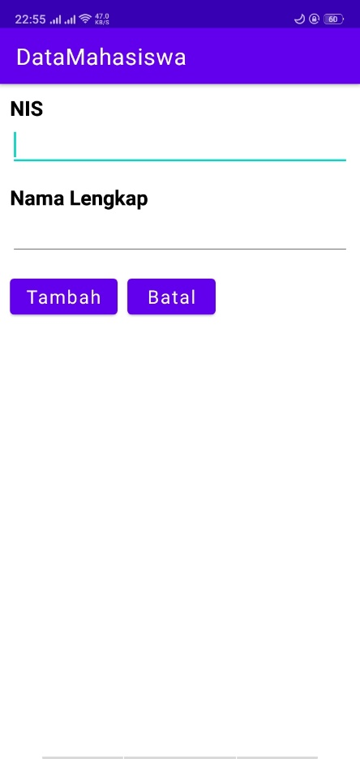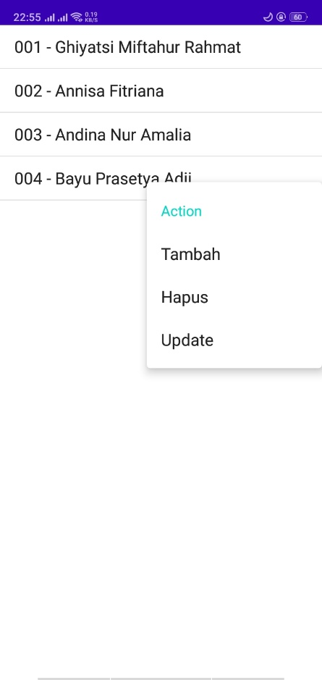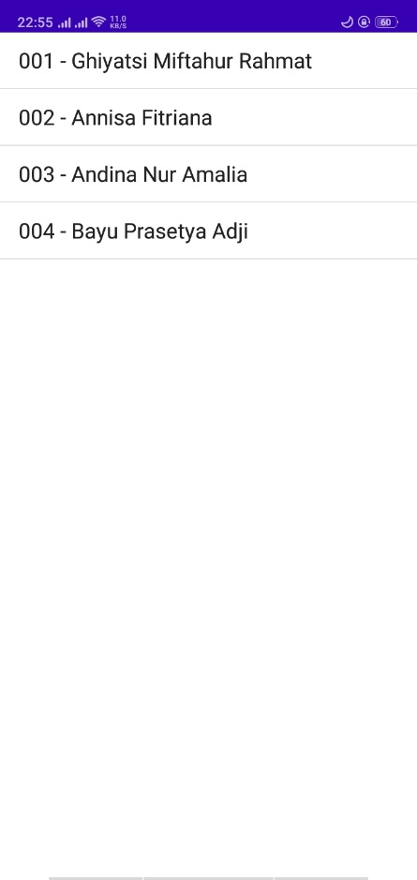

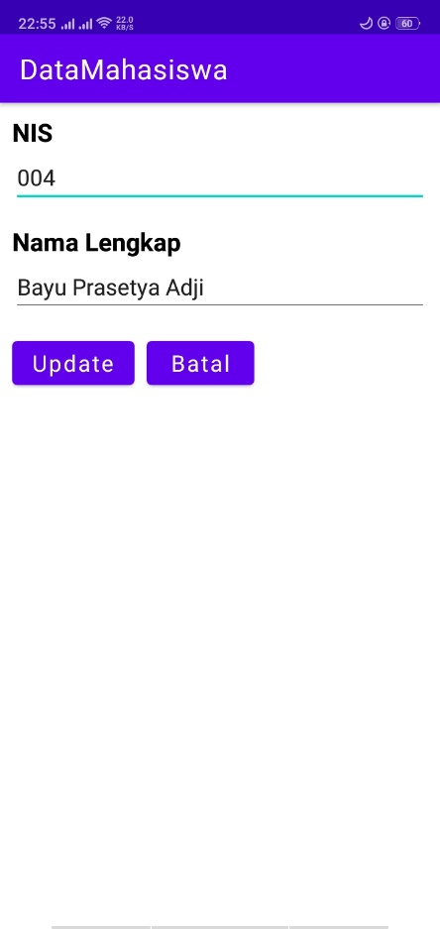

**String.xml**

<resources>

    <string name="app_name">DataMahasiswa</string>

    <string name="batal">Batal</string>

    <string name="nama_lengkap">Nama Lengkap</string>

    <string name="nis">NIS</string>

    <string name="update">Update</string>

    <string name="tambah">Tambah</string>

</resources>

**Layout**

**Activity_main.xml**

<?xml version="1.0" encoding="utf-8"?>

<LinearLayout xmlns:android="http://schemas.android.com/apk/res/android"

    xmlns:app="http://schemas.android.com/apk/res-auto"

    xmlns:tools="http://schemas.android.com/tools"

    android:layout_width="match_parent"

    android:layout_height="match_parent"

    android:layout_marginVertical="10dp"

    android:layout_marginHorizontal="10dp"

    android:orientation="vertical"

    tools:context=".MainActivity">

    <ListView

        android:id="@+id/simple_list_item_1"

        android:layout_width="match_parent"

        android:layout_height="match_parent"/>

</LinearLayout>

**Activity_tambah.xml**

<?xml version="1.0" encoding="utf-8"?>

<LinearLayout xmlns:android="http://schemas.android.com/apk/res/android"

    xmlns:app="http://schemas.android.com/apk/res-auto"

    xmlns:tools="http://schemas.android.com/tools"

    android:layout_width="match_parent"

    android:layout_height="match_parent"

    android:orientation="vertical"

    android:layout_marginHorizontal="10dp"

    android:layout_marginVertical="10dp"

    tools:context=".Tambah">

    <TextView

        android:layout_width="match_parent"

        android:layout_height="wrap_content"

        android:text="@string/nis"

        android:textColor="@color/black"

        android:textSize="18sp"

        android:textStyle="bold"/>

    <EditText

        android:id="@+id/inputnis"

        android:layout_width="match_parent"

        android:layout_height="wrap_content"

        android:textSize="16sp"

        android:layout_marginBottom="15dp"/>

    <TextView

        android:layout_width="match_parent"

        android:layout_height="wrap_content"

        android:text="@string/nama_lengkap"

        android:textColor="@color/black"

        android:textSize="18sp"

        android:textStyle="bold"/>

    <EditText

        android:id="@+id/inputnama"

        android:layout_width="match_parent"

        android:layout_height="wrap_content"

        android:textSize="16sp"

        android:layout_marginBottom="15dp"/>

    <LinearLayout

        android:layout_width="match_parent"

        android:layout_height="wrap_content"

        android:orientation="horizontal">

        <Button

            android:layout_width="wrap_content"

            android:layout_height="wrap_content"

            android:id="@+id/btnTambah"

            android:text="@string/tambah"

            android:textAllCaps="false"

            android:layout_marginRight="10dp"

            android:textSize="16sp"/>

        <Button

            android:layout_width="wrap_content"

            android:layout_height="wrap_content"

            android:id="@+id/btnCancel"

            android:text="@string/batal"

            android:textAllCaps="false"

            android:textSize="16sp"/>

    </LinearLayout>

</LinearLayout>

**Activity_update.xml**

<?xml version="1.0" encoding="utf-8"?>

<LinearLayout xmlns:android="http://schemas.android.com/apk/res/android"

    xmlns:app="http://schemas.android.com/apk/res-auto"

    xmlns:tools="http://schemas.android.com/tools"

    android:layout_width="match_parent"

    android:layout_height="match_parent"

    android:orientation="vertical"

    android:layout_marginHorizontal="10dp"

    android:layout_marginVertical="10dp"

    tools:context=".Update">

    <TextView

        android:layout_width="match_parent"

        android:layout_height="wrap_content"

        android:text="@string/nis"

        android:textColor="@color/black"

        android:textSize="18sp"

        android:textStyle="bold"/>

    <EditText

        android:id="@+id/updatenis"

        android:layout_width="match_parent"

        android:layout_height="wrap_content"

        android:textSize="16sp"

        android:layout_marginBottom="15dp"

        android:enabled="false"/>

    <TextView

        android:layout_width="match_parent"

        android:layout_height="wrap_content"

        android:text="@string/nama_lengkap"

        android:textColor="@color/black"

        android:textSize="18sp"

        android:textStyle="bold"/>

    <EditText

        android:id="@+id/updatenama"

        android:layout_width="match_parent"

        android:layout_height="wrap_content"

        android:textSize="16sp"

        android:layout_marginBottom="15dp"/>

    <LinearLayout

        android:layout_width="match_parent"

        android:layout_height="wrap_content"

        android:orientation="horizontal">

        <Button

            android:layout_width="wrap_content"

            android:layout_height="wrap_content"

            android:id="@+id/btnUpdate"

            android:text="@string/update"

            android:textAllCaps="false"

            android:layout_marginRight="10dp"

            android:textSize="16sp"/>

        <Button

            android:layout_width="wrap_content"

            android:layout_height="wrap_content"

            android:id="@+id/btnCancel"

            android:text="@string/batal"

            android:textAllCaps="false"

            android:textSize="16sp"/>

    </LinearLayout>

</LinearLayout>

**Java**

**DatabaseHendler.java**

package com.example.datamahasiswa;

import android.content.ContentValues;

import android.content.Context;

import android.database.Cursor;

import android.database.sqlite.SQLiteDatabase;

import android.database.sqlite.SQLiteOpenHelper;

import java.util.ArrayList;

import java.util.List;

public class DatabaseHandler extends SQLiteOpenHelper {

    private static final int DATABASE_VERSION= 1;

    // NamaDatabase

    private static final String DATABASE_NAME= "Sekolah";

    // NamaTable

    private static final String TABLE_SISWA= "Siswa";

    // NamaKolomTable Siswa

    private static final String KEY_NIS= "nis";

    private static final String KEY_NAMA= "nama";

    public DatabaseHandler(Context context) {

    // TODOAuto-generated constructor stub

        super(context, DATABASE_NAME, null, DATABASE_VERSION);

    }

    // Create Table

    @Override

    public void onCreate(SQLiteDatabase db) {

    // TODOAuto-generated method stub

        String query_table_siswa = "CREATE TABLE "+

                TABLE_SISWA+ "("

                + KEY_NIS+ " TEXT PRIMARY KEY,"+ KEY_NAMA+ " TEXT)";

        db.execSQL(query_table_siswa);

    }

    @Override

    public void onUpgrade(SQLiteDatabase db, int oldVersion, int newVersion) {

    // TODOAuto-generated method stub

    // Drop older table if existed

        db.execSQL("DROP TABLE IF EXISTS "+ TABLE_SISWA);

    // Create tables again

        onCreate(db);

    }

    // add new siswa

    public void addSiswa(Siswa siswa) {

        SQLiteDatabase db = this.getWritableDatabase();

        ContentValues values = new ContentValues();

        values.put(KEY_NIS, siswa.getNis());

        values.put(KEY_NAMA, siswa.getNama());

// Inserting Row

        db.insert(TABLE_SISWA, null, values);

        db.close();

    }

    // read siswa

    public Siswa getSiswa(String nis) {

        SQLiteDatabase db = this.getReadableDatabase();

        Cursor cursor = db.query(TABLE_SISWA, new String[] {KEY_NIS, KEY_NAMA}, KEY_NIS+ "=?", new String[] {nis}, null, null, null, null);

        if(cursor != null)

            cursor.moveToFirst();

        Siswa siswa = new Siswa(cursor.getString(0),

                cursor.getString(1));

        return siswa;

    }

    //read all siswa

    public List<Siswa> getSemuaSiswa() {

        List<Siswa> siswaList = new ArrayList<Siswa>();

        String query_select_siswa = "SELECT * FROM "+ TABLE_SISWA;

        SQLiteDatabase db = this.getWritableDatabase();

        Cursor cursor = db.rawQuery(query_select_siswa,null);

        if(cursor.moveToFirst()) {

            do{

                Siswa siswa = new Siswa(cursor.getString(0),

                        cursor.getString(1));

                siswaList.add(siswa);

            } while(cursor.moveToNext());

        }

        return siswaList;

    }

    //delete data siswa

    public void deleteSiswa(Siswa siswa) {

        SQLiteDatabase db = this.getWritableDatabase();

        db.delete(TABLE_SISWA, KEY_NIS+ "='"+ siswa.getNis()+"'",null);

        db.close();

        System.out.println("Data terhapus "+siswa.getNis());

    }

    public void deleteRow(String xnis) {

        SQLiteDatabase db = this.getWritableDatabase();

        db.delete(TABLE_SISWA, KEY_NIS+ "='"+ xnis+"'",null);

        db.close();

        System.out.println("Data terhapus "+xnis);

    }

    public void updateMethod(String nis, String nama){

        SQLiteDatabase db = this.getWritableDatabase();

        db.execSQL("update "+TABLE_SISWA+" set nama='"+nama+ "' where nis='"+nis+"'");

        db.close();

        System.out.println("Data sudah di update "+nis);

    }

}

**Mainactivity.java**

package com.example.datamahasiswa;

import androidx.appcompat.app.AppCompatActivity;

import android.app.ListActivity;

import android.content.Intent;

import android.os.Bundle;

import android.util.Log;

import android.view.ContextMenu;

import android.view.Menu;

import android.view.MenuInflater;

import android.view.MenuItem;

import android.view.View;

import android.widget.AdapterView;

import android.widget.ArrayAdapter;

import java.util.List;

public class MainActivity extends ListActivity {

    String dataSiswa[] = null;

    String dS[] = null;

    @Override

    protected void onCreate(Bundle savedInstanceState) {

        super.onCreate(savedInstanceState);

        //setContentView(R.layout.activity_main);

        // Tambah Siswa

        DatabaseHandler db = new DatabaseHandler(this);

        // Membaca Semua Siswa

        Log.d("Baca Siswa: ", "Membaca Semua Data Siswa..");

        List<Siswa> siswa = db.getSemuaSiswa();

        dataSiswa= new String[siswa.size()];

        dS= new String[siswa.size()];

        int i=0;

        for(Siswa s : siswa) {

            String log = "NIS: "+ s.getNis() + ",Nama: "+

                    s.getNama();

            Log.d("Name: ", log);

            dataSiswa[i] = s.getNis() + " - "+ s.getNama();

            dS[i] = s.getNis();

            i++;

        }

        // check data

        if(i==0)

        {

            Log.d("Tambah Siswa: ", "Menambah Data Siswa..");

            db.addSiswa(new Siswa("001", "Ghiyatsi Miftahur Rahmat"));

            db.addSiswa(new Siswa("002", "Annisa Fitriana"));

            db.addSiswa(new Siswa("003", "Andina Nur Amalia"));

            db.addSiswa(new Siswa("004", "Najwa Aulia Dhofiroh"));

        }

        setListAdapter(new ArrayAdapter<Object>(this, android.R.layout.simple_list_item_1, dataSiswa));

        registerForContextMenu(getListView());

    }

    @Override

    public void onCreateContextMenu(ContextMenu menu, View v, ContextMenu.ContextMenuInfo menuInfo) {

// TODOAuto-generated method stub

        super.onCreateContextMenu(menu, v, menuInfo);

        menu.setHeaderTitle("Action");

        menu.add(0,0,0,"Tambah");

        menu.add(0,1,1,"Hapus");

        menu.add(0,2,2,"Update");

    }

    @Override

    public boolean onContextItemSelected(MenuItem item) {

// TODOAuto-generated method stub

        try{

            switch(item.getItemId()){

                case 0:{

                    Class c = Class.forName("com.example.datamahasiswa.Tambah");

                    Intent i = new Intent(MainActivity.this, c);

                    startActivity(i);break;

                }

                case 1:{

                    DatabaseHandler db = new DatabaseHandler(this);

                    AdapterView.AdapterContextMenuInfo info = (AdapterView.AdapterContextMenuInfo) item.getMenuInfo();

                    String[] args = {String.valueOf(info.id) };

                    int xpos=Integer.parseInt(args[0]);

                    db.deleteRow(dS[xpos]);

                    Class c = Class.forName("com.example.datamahasiswa.MainActivity");

                    Intent i = new Intent(MainActivity.this, c);

                    startActivity(i);

                    break;

                }

                case 2:{

                    DatabaseHandler db = new DatabaseHandler(this);

                    AdapterView.AdapterContextMenuInfo info =(AdapterView.AdapterContextMenuInfo) item.getMenuInfo();

                    String[] args ={String.valueOf(info.id)};

                    Log.d("args0 : ",args[0]);

                    int xpos=Integer.parseInt(args[0]);

                    db.getSiswa(dS[xpos]);

                    String namax=db.getSiswa(dS[xpos]).getNama();

                    Intent i = new Intent(this, Update.class);

                    Bundle bun = new Bundle();

                    bun.putString("nis", dS[xpos]);

                    bun.putString("nama", namax);

                    i.putExtras(bun);

                    startActivity(i); break;

                }

            }

        }catch(ClassNotFoundException e) {

            // TODOAuto-generated catch block

            e.printStackTrace();

        }

        return true;

    }

}

**Siswa.java**

package com.example.datamahasiswa;

public class Siswa {

    private String nis;

    private String nama;

    public Siswa() {

    }

    public Siswa(String nis, String nama) {

        this.nis= nis;

        this.nama= nama;

    }

    public String getNis() {

        return nis;

    }

    public void setNis(String nis) {

        this.nis= nis;

    }

    public String getNama() {

        return nama;

    }

    public void setNama(String nama) {

        this.nama= nama;

    }

}

**Tambah.java**

package com.example.datamahasiswa;

import androidx.appcompat.app.AppCompatActivity;

import android.content.Intent;

import android.os.Bundle;

import android.view.View;

import android.widget.Button;

import android.widget.EditText;

public class Tambah extends AppCompatActivity {

    @Override

    protected void onCreate(Bundle savedInstanceState) {

        super.onCreate(savedInstanceState);

        setContentView(R.layout.activity_tambah);

        final DatabaseHandler db = new DatabaseHandler(this);

        final EditText editNis = (EditText) findViewById(R.id.inputnis);

        final EditText editNama = (EditText) findViewById(R.id.inputnama);

        Button btnTambah = (Button) findViewById(R.id.btnTambah);

        Button btnBatal = (Button) findViewById(R.id.btnCancel);

        btnTambah.setOnClickListener(new View.OnClickListener()

        {

            @Override

            public void onClick(View v) {

                String nis = editNis.getText().toString();

                String nama = editNama.getText().toString();

                db.addSiswa(new Siswa(nis, nama));

                editNis.setText("");

                editNama.setText("");

                try{

                    Class c = Class.forName("com.example.datamahasiswa.MainActivity");

                    Intent i = new Intent(Tambah.this, c);

                    startActivity(i);

                } catch(ClassNotFoundException e) {

                    e.printStackTrace();

                }

            }

        });

        btnBatal.setOnClickListener(new View.OnClickListener() {

            public void onClick(View v) {

                try {

                    Class c = Class.forName("com.example.datamahasiswa.MainActivity");

                    Intent i=new Intent(Tambah.this,c);

                    startActivity(i);

                } catch (ClassNotFoundException e) {

                    e.printStackTrace();

                }

            }

        });

    }

}

**Update.java**

package com.example.datamahasiswa;

import androidx.appcompat.app.AppCompatActivity;

import android.content.Intent;

import android.os.Bundle;

import android.view.View;

import android.widget.Button;

import android.widget.EditText;

public class Update extends AppCompatActivity {

    private String xnis,xnama;

    @Override

    protected void onCreate(Bundle savedInstanceState) {

        super.onCreate(savedInstanceState);

        setContentView(R.layout.activity_update);

        final DatabaseHandler db = new DatabaseHandler(this);

        final EditText editNis = (EditText)findViewById(R.id.updatenis);

        final EditText editNama = (EditText) findViewById(R.id.updatenama);

        Button btnTambah = (Button) findViewById(R.id.btnUpdate);

        Button btnBatal = (Button) findViewById(R.id.btnCancel);

        // ambil data siswa

        Bundle bun = this.getIntent().getExtras();

        xnis = bun.getString("nis");

        xnama = bun.getString("nama");

        //masukkan data siswa

        editNama.setText(xnama);

        editNis.setText(xnis);

        btnTambah.setOnClickListener(new View.OnClickListener()

        {

            @Override

            public void onClick(View v) {

                String nis = editNis.getText().toString();

                String nama = editNama.getText().toString();

                //db.addSiswa(new Siswa(nis, nama));

                //db.updateData(nis,nama);

                db.updateMethod(nis,nama);

                editNis.setText("");

                editNama.setText("");

                try{

                    Class c= Class.forName("com.example.datamahasiswa.MainActivity");

                    Intent i = new Intent(Update.this, c);

                    startActivity(i);

                } catch(ClassNotFoundException e) {

                    e.printStackTrace();

                }

            }

        });

        btnBatal.setOnClickListener(new View.OnClickListener()

        {public void onClick(View v) {

            try {

                Class c = Class.forName("com.example.datamahasiswa.MainActivity");

                Intent i=new Intent(Update.this,c);

                startActivity(i);

            } catch (ClassNotFoundException e) {

                e.printStackTrace();

            }

        }

        });

    }

}

**AndroidManifest**

<?xml version="1.0" encoding="utf-8"?>

<manifest xmlns:android="http://schemas.android.com/apk/res/android"

    package="com.example.datamahasiswa">

    <application

        android:allowBackup="true"

        android:icon="@mipmap/ic_launcher"

        android:label="@string/app_name"

        android:roundIcon="@mipmap/ic_launcher_round"

        android:supportsRtl="true"

        android:theme="@style/Theme.DataMahasiswa">

        <activity

            android:name=".Tambah"

            android:exported="false" />

        <activity

            android:name=".Update"

            android:exported="false" />

        <activity

            android:name=".MainActivity"

            android:exported="true">

            <intent-filter>

                <action android:name="android.intent.action.MAIN" />

                <category android:name="android.intent.category.LAUNCHER" />

            </intent-filter>

        </activity>

    </application>

</manifest>

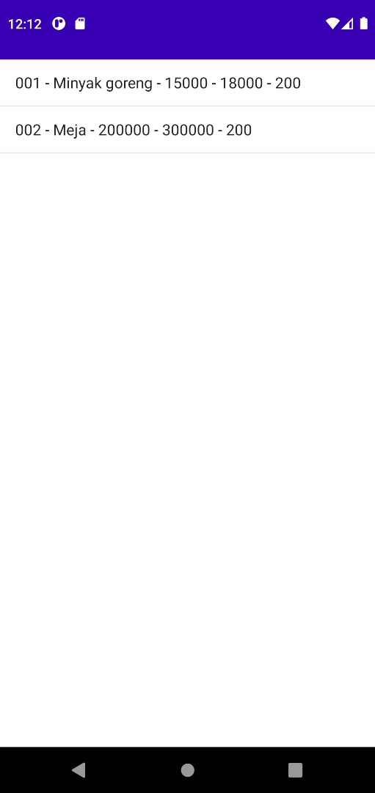**Data Barang**

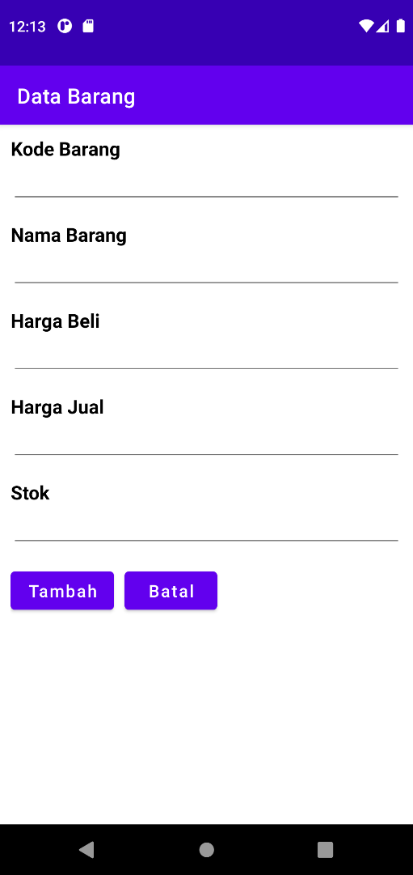

**String.xml**

<resources>

    <string name="app_name">Data Barang</string>

    <string name="batal">Batal</string>

    <string name="nama_lengkap">Nama Barang</string>

    <string name="nis">Kode Barang</string>

    <string name="update">Update</string>

    <string name="tambah">Tambah</string>

    <string name="harga_beli">Harga Beli</string>

    <string name="harga_jual">Harga Jual</string>

    <string name="stok">Stok</string>

</resources>

**Layout**

**Activity_main**

<?xml version="1.0" encoding="utf-8"?>

<LinearLayout xmlns:android="http://schemas.android.com/apk/res/android"

    xmlns:app="http://schemas.android.com/apk/res-auto"

    xmlns:tools="http://schemas.android.com/tools"

    android:layout_width="match_parent"

    android:layout_height="match_parent"

    android:layout_marginVertical="10dp"

    android:layout_marginHorizontal="10dp"

    android:orientation="vertical"

    tools:context=".MainActivity">

    <ListView

        android:id="@+id/simple_list_item_1"

        android:layout_width="match_parent"

        android:layout_height="match_parent"/>

</LinearLayout>

**Activity_tambah**

<?xml version="1.0" encoding="utf-8"?>

<LinearLayout xmlns:android="http://schemas.android.com/apk/res/android"

    xmlns:app="http://schemas.android.com/apk/res-auto"

    xmlns:tools="http://schemas.android.com/tools"

    android:layout_width="match_parent"

    android:layout_height="match_parent"

    android:orientation="vertical"

    android:layout_marginHorizontal="10dp"

    android:layout_marginVertical="10dp"

    tools:context=".Tambah">

    <TextView

        android:layout_width="match_parent"

        android:layout_height="wrap_content"

        android:text="@string/nis"

        android:textColor="@color/black"

        android:textSize="18sp"

        android:textStyle="bold"/>

    <EditText

        android:id="@+id/inputkdbrg"

        android:layout_width="match_parent"

        android:layout_height="wrap_content"

        android:textSize="16sp"

        android:layout_marginBottom="15dp" />

    <TextView

        android:layout_width="match_parent"

        android:layout_height="wrap_content"

        android:text="@string/nama_lengkap"

        android:textColor="@color/black"

        android:textSize="18sp"

        android:textStyle="bold"/>

    <EditText

        android:id="@+id/inputnama"

        android:layout_width="match_parent"

        android:layout_height="wrap_content"

        android:textSize="16sp"

        android:layout_marginBottom="15dp"/>

    <TextView

        android:layout_width="match_parent"

        android:layout_height="wrap_content"

        android:text="@string/harga_beli"

        android:textColor="@color/black"

        android:textSize="18sp"

        android:textStyle="bold"/>

    <EditText

        android:id="@+id/inputbeli"

        android:layout_width="match_parent"

        android:layout_height="wrap_content"

        android:textSize="16sp"

        android:layout_marginBottom="15dp"/>

    <TextView

        android:layout_width="match_parent"

        android:layout_height="wrap_content"

        android:text="@string/harga_jual"

        android:textColor="@color/black"

        android:textSize="18sp"

        android:textStyle="bold"/>

    <EditText

        android:id="@+id/inputjual"

        android:layout_width="match_parent"

        android:layout_height="wrap_content"

        android:textSize="16sp"

        android:layout_marginBottom="15dp"/>

    <TextView

        android:layout_width="match_parent"

        android:layout_height="wrap_content"

        android:text="@string/stok"

        android:textColor="@color/black"

        android:textSize="18sp"

        android:textStyle="bold"/>

    <EditText

        android:id="@+id/inputstok"

        android:layout_width="match_parent"

        android:layout_height="wrap_content"

        android:textSize="16sp"

        android:layout_marginBottom="15dp"/>

    <LinearLayout

        android:layout_width="match_parent"

        android:layout_height="wrap_content"

        android:orientation="horizontal">

        <Button

            android:layout_width="wrap_content"

            android:layout_height="wrap_content"

            android:id="@+id/btnTambah"

            android:text="@string/tambah"

            android:textAllCaps="false"

            android:layout_marginRight="10dp"

            android:textSize="16sp"/>

        <Button

            android:layout_width="wrap_content"

            android:layout_height="wrap_content"

            android:id="@+id/btnCancel"

            android:text="@string/batal"

            android:textAllCaps="false"

            android:textSize="16sp"/>

    </LinearLayout>

</LinearLayout>

**Activity_update**

<?xml version="1.0" encoding="utf-8"?>

<LinearLayout xmlns:android="http://schemas.android.com/apk/res/android"

    xmlns:app="http://schemas.android.com/apk/res-auto"

    xmlns:tools="http://schemas.android.com/tools"

    android:layout_width="match_parent"

    android:layout_height="match_parent"

    android:orientation="vertical"

    android:layout_marginHorizontal="10dp"

    android:layout_marginVertical="10dp"

    tools:context=".Update">

    <TextView

        android:layout_width="match_parent"

        android:layout_height="wrap_content"

        android:text="@string/nis"

        android:textColor="@color/black"

        android:textSize="18sp"

        android:textStyle="bold"/>

    <EditText

        android:id="@+id/updatekdbrg"

        android:layout_width="match_parent"

        android:layout_height="wrap_content"

        android:textSize="16sp"

        android:layout_marginBottom="15dp"

        android:enabled="false"/>

    <TextView

        android:layout_width="match_parent"

        android:layout_height="wrap_content"

        android:text="@string/nama_lengkap"

        android:textColor="@color/black"

        android:textSize="18sp"

        android:textStyle="bold"/>

    <EditText

        android:id="@+id/updatenama"

        android:layout_width="match_parent"

        android:layout_height="wrap_content"

        android:textSize="16sp"

        android:layout_marginBottom="15dp"/>

    <TextView

        android:layout_width="match_parent"

        android:layout_height="wrap_content"

        android:text="@string/harga_beli"

        android:textColor="@color/black"

        android:textSize="18sp"

        android:textStyle="bold"/>

    <EditText

        android:id="@+id/updatebeli"

        android:layout_width="match_parent"

        android:layout_height="wrap_content"

        android:textSize="16sp"

        android:layout_marginBottom="15dp"/>

    <TextView

        android:layout_width="match_parent"

        android:layout_height="wrap_content"

        android:text="@string/harga_jual"

        android:textColor="@color/black"

        android:textSize="18sp"

        android:textStyle="bold"/>

    <EditText

        android:id="@+id/updatejual"

        android:layout_width="match_parent"

        android:layout_height="wrap_content"

        android:textSize="16sp"

        android:layout_marginBottom="15dp"/>

    <TextView

        android:layout_width="match_parent"

        android:layout_height="wrap_content"

        android:text="@string/stok"

        android:textColor="@color/black"

        android:textSize="18sp"

        android:textStyle="bold"/>

    <EditText

        android:id="@+id/updatestok"

        android:layout_width="match_parent"

        android:layout_height="wrap_content"

        android:textSize="16sp"

        android:layout_marginBottom="15dp"/>

    <LinearLayout

        android:layout_width="match_parent"

        android:layout_height="wrap_content"

        android:orientation="horizontal">

        <Button

            android:layout_width="wrap_content"

            android:layout_height="wrap_content"

            android:id="@+id/btnUpdate"

            android:text="@string/update"

            android:textAllCaps="false"

            android:layout_marginRight="10dp"

            android:textSize="16sp"/>

        <Button

            android:layout_width="wrap_content"

            android:layout_height="wrap_content"

            android:id="@+id/btnCancel"

            android:text="@string/batal"

            android:textAllCaps="false"

            android:textSize="16sp"/>

    </LinearLayout>

</LinearLayout>

**Java**

**DatabaseHandler.java**

package com.example.databarang;

import android.content.ContentValues;

import android.content.Context;

import android.database.Cursor;

import android.database.sqlite.SQLiteDatabase;

import android.database.sqlite.SQLiteOpenHelper;

import java.util.ArrayList;

import java.util.List;

public class DatabaseHandler extends SQLiteOpenHelper {

    private static final int DATABASE_VERSION= 1;

    // NamaDatabase

    private static final String DATABASE_NAME= "DataBarang";

    // NamaTable

    private static final String TABLE_BARANG= "Barang";

    // NamaKolomTable Siswa

    private static final String KEY_KDBRG= "kdbarang";

    private static final String KEY_NAMA= "nama";

    private static final String KEY_BELI= "hgbeli";

    private static final String KEY_JUAL= "hgjual";

    private static final String KEY_STOK= "jmlstok";

    public DatabaseHandler(Context context) {

    // TODOAuto-generated constructor stub

        super(context, DATABASE_NAME, null, DATABASE_VERSION);

    }

    // Create Table

    @Override

    public void onCreate(SQLiteDatabase db) {

    // TODOAuto-generated method stub

        String query_table_barang = "CREATE TABLE "+ TABLE_BARANG + "("+KEY_KDBRG + " TEXT PRIMARY KEY, "+ KEY_NAMA + " TEXT NOT NULL, "+ KEY_BELI +" TEXT NOT NULL, "+ KEY_JUAL +" TEXT NOT NULL, "+ KEY_STOK +" TEXT NOT NULL)";

        db.execSQL(query_table_barang);

    }

    @Override

    public void onUpgrade(SQLiteDatabase db, int oldVersion, int newVersion) {

    // TODOAuto-generated method stub

    // Drop older table if existed

        db.execSQL("DROP TABLE IF EXISTS "+ TABLE_BARANG);

    // Create tables again

        onCreate(db);

    }

    // add new barang

    public void addBarang(Barang barang) {

        SQLiteDatabase db = this.getWritableDatabase();

        ContentValues values = new ContentValues();

        values.put(KEY_KDBRG, barang.getKdbarang());

        values.put(KEY_NAMA, barang.getNama());

        values.put(KEY_BELI, barang.getBeli());

        values.put(KEY_JUAL, barang.getJual());

        values.put(KEY_STOK, barang.getStok());

// Inserting Row

        db.insert(TABLE_BARANG, null, values);

        db.close();

    }

    // read barang

    public Barang getBarang(String kdbarang) {

        SQLiteDatabase db = this.getReadableDatabase();

        Cursor cursor = db.query(TABLE_BARANG, new String[] {KEY_KDBRG, KEY_NAMA}, KEY_KDBRG+ "=?", new String[] {kdbarang}, null, null, null, null);

        if(cursor != null)

            cursor.moveToFirst();

        Barang barang = new Barang(cursor.getString(0), cursor.getString(1), cursor.getInt(2), cursor.getInt(3), cursor.getInt(4) );

        return barang;

    }

    //read all siswa

    public List<Barang> getSemuaBarang() {

        List<Barang> barangList = new ArrayList<Barang>();

        String query_select_barang = "SELECT * FROM "+ TABLE_BARANG;

        SQLiteDatabase db = this.getWritableDatabase();

        Cursor cursor = db.rawQuery(query_select_barang,null);

        if(cursor.moveToFirst()) {

            do{

                Barang barang = new Barang(cursor.getString(0), cursor.getString(1), cursor.getInt(2), cursor.getInt(3), cursor.getInt(4) );

                barangList.add(barang);

            } while(cursor.moveToNext());

        }

        return barangList;

    }

    //delete data barang

    public void deleteBarang(Barang barang) {

        SQLiteDatabase db = this.getWritableDatabase();

        db.delete(TABLE_BARANG, KEY_KDBRG+ "='"+ barang.getKdbarang()+"'",null);

        db.close();

        System.out.println("Data terhapus "+barang.getKdbarang());

    }

    public void deleteRow(String xkdbarang) {

        SQLiteDatabase db = this.getWritableDatabase();

        db.delete(TABLE_BARANG, KEY_KDBRG+ "='"+ xkdbarang+"'",null);

        db.close();

        System.out.println("Data terhapus "+xkdbarang);

    }

    public void updateMethod(String kdbarang, String nama, int beli, int jual, int stok){

        SQLiteDatabase db = this.getWritableDatabase();

        db.execSQL("update "+TABLE_BARANG + " set nama='" + nama + "'" + " ,beli=" + beli + " ,jual=" + jual + " ,stok=" + stok +" where kdbarang='" + kdbarang + "'") ;

        db.close();

        System.out.println("Data sudah di update "+kdbarang);

    }

}

**Barang.java**

package com.example.databarang;

public class Barang {

    private String kdbarang;

    private String nama;

    private int beli;

    private int jual;

    private int stok;

    public Barang(String kdbarang, String nama, int beli, int jual, int stok) {

        this.kdbarang= kdbarang;

        this.nama= nama;

        this.beli= beli;

        this.jual= jual;

        this.stok= stok;

    }

    public String getKdbarang() {

        return kdbarang;

    }

    public void setKdbarang(String kdbarang) {

        this.kdbarang= kdbarang;

    }

    public String getNama() {

        return nama;

    }

    public void setNama(String nama) {

        this.nama= nama;

    }

    public int getBeli() {

        return beli;

    }

    public void setBeli(int beli) {

        this.beli = beli;

    }

    public int getJual() {

        return jual;

    }

    public void setJual(int jual) {

        this.jual = jual;

    }

    public int getStok() {

        return stok;

    }

    public void setStok(int stok) {

        this.stok = stok;

    }

}

**Mainactivity.java**

package com.example.databarang;

import androidx.appcompat.app.AppCompatActivity;

import android.app.ListActivity;

import android.content.Intent;

import android.os.Bundle;

import android.util.Log;

import android.view.ContextMenu;

import android.view.MenuItem;

import android.view.View;

import android.widget.AdapterView;

import android.widget.ArrayAdapter;

import java.util.List;

public class MainActivity extends ListActivity {

    String dataBarang[] = null;

    String dS[] = null;

    @Override

    protected void onCreate(Bundle savedInstanceState) {

        super.onCreate(savedInstanceState);

        //setContentView(R.layout.activity_main);

        // Tambah Siswa

        DatabaseHandler db = new DatabaseHandler(this);

        // Membaca Semua Siswa

        Log.d("Baca Siswa: ", "Membaca Semua Data Siswa..");

        List<Barang> barang = db.getSemuaBarang();

        dataBarang= new String[barang.size()];

        dS= new String[barang.size()];

        int i=0;

        for(Barang s : barang) {

            /*String log = "Kode Barang: "+ s.getKdbarang() + ",Nama: "+ s.getNama() + ",Harga Beli: "+ s.getJual() + ",Harga Jual: "+ s.getJual() + ",Stok: "+ s.getStok() ;

            Log.d("Name: ", log);*/

            dataBarang[i] = s.getKdbarang() + " - "+ s.getNama() + " - "+ s.getBeli() + " - "+ s.getJual() + " - "+ s.getStok();

            dS[i] = s.getKdbarang();

            i++;

        }

        // check data

        if(i==0)

        {

            Log.d("Tambah Barang: ", "Menambah Data Barang..");

            db.addBarang(new Barang("001", "Minyak goreng", 15000, 18000, 200));

            db.addBarang(new Barang("002", "Meja", 200000, 300000, 200));

            db.addBarang(new Barang("003", "Kursi", 150000, 200000, 200));

            db.addBarang(new Barang("004", "Mouse", 300000, 400000, 200));

        }

        setListAdapter(new ArrayAdapter<Object>(this, android.R.layout.simple_list_item_1, dataBarang));

        registerForContextMenu(getListView());

    }

    @Override

    public void onCreateContextMenu(ContextMenu menu, View v, ContextMenu.ContextMenuInfo menuInfo) {

// TODOAuto-generated method stub

        super.onCreateContextMenu(menu, v, menuInfo);

        menu.setHeaderTitle("Action");

        menu.add(0,0,0,"Tambah");

        menu.add(0,1,1,"Hapus");

        menu.add(0,2,2,"Update");

    }

    @Override

    public boolean onContextItemSelected(MenuItem item) {

// TODOAuto-generated method stub

        try{

            switch(item.getItemId()){

                case 0:{

                    Class c = Class.forName("com.example.databarang.Tambah");

                    Intent i = new Intent(MainActivity.this, c);

                    startActivity(i);break;

                }

                case 1:{

                    DatabaseHandler db = new DatabaseHandler(this);

                    AdapterView.AdapterContextMenuInfo info = (AdapterView.AdapterContextMenuInfo) item.getMenuInfo();

                    String[] args = {String.valueOf(info.id) };

                    int xpos=Integer.parseInt(args[0]);

                    db.deleteRow(dS[xpos]);

                    Class c = Class.forName("com.example.databarang.MainActivity");

                    Intent i = new Intent(MainActivity.this, c);

                    startActivity(i);

                    break;

                }

                case 2:{

                    DatabaseHandler db = new DatabaseHandler(this);

                    AdapterView.AdapterContextMenuInfo info =(AdapterView.AdapterContextMenuInfo) item.getMenuInfo();

                    String[] args ={String.valueOf(info.id)};

                    Log.d("args0 : ",args[0]);

                    int xpos=Integer.parseInt(args[0]);

                    db.getBarang(dS[xpos]);

                    String namax=db.getBarang(dS[xpos]).getNama();

                    Intent i = new Intent(this, Update.class);

                    Bundle bun = new Bundle();

                    bun.putString("kdbarang", dS[xpos]);

                    bun.putString("nama", namax);

                    i.putExtras(bun);

                    startActivity(i); break;

                }

            }

        }catch(ClassNotFoundException e) {

            // TODOAuto-generated catch block

            e.printStackTrace();

        }

        return true;

    }

}

**Tambah.java**

package com.example.databarang;

import androidx.appcompat.app.AppCompatActivity;

import android.content.Intent;

import android.os.Bundle;

import android.view.View;

import android.widget.Button;

import android.widget.EditText;

public class Tambah extends AppCompatActivity {

    @Override

    protected void onCreate(Bundle savedInstanceState) {

        super.onCreate(savedInstanceState);

        setContentView(R.layout.activity_tambah);

        final DatabaseHandler db = new DatabaseHandler(this);

        final EditText editKdbrg = (EditText)findViewById(R.id.inputkdbrg);

        final EditText editNama = (EditText) findViewById(R.id.inputnama);

        final EditText editBeli = (EditText) findViewById(R.id.inputbeli);

        final EditText editJual = (EditText) findViewById(R.id.inputjual);

        final EditText editStok = (EditText) findViewById(R.id.inputstok);

        Button btnTambah = (Button) findViewById(R.id.btnTambah);

        Button btnBatal = (Button) findViewById(R.id.btnCancel);

        btnTambah.setOnClickListener(new View.OnClickListener()

        {

            @Override

            public void onClick(View v) {

                String kdbarang = editKdbrg.getText().toString();

                String nama = editNama.getText().toString();

                int beli = Integer.valueOf(editBeli.getText().toString());

                int jual = Integer.valueOf(editJual.getText().toString());

                int stok = Integer.valueOf(editStok.getText().toString());

                db.addBarang(new Barang(kdbarang,nama,beli,jual,stok));

                editKdbrg.setText("");

                editNama.setText("");

                editBeli.setText("");

                editJual.setText("");

                editStok.setText("");

                try{

                    Class c = Class.forName("com.example.databarang.MainActivity");

                    Intent i = new Intent(Tambah.this, c);

                    startActivity(i);

                } catch(ClassNotFoundException e) {

                    e.printStackTrace();

                }

            }

        });

        btnBatal.setOnClickListener(new View.OnClickListener() {

            public void onClick(View v) {

                try {

                    Class c = Class.forName("com.example.databarang.MainActivity");

                    Intent i=new Intent(Tambah.this,c);

                    startActivity(i);

                } catch (ClassNotFoundException e) {

                    e.printStackTrace();

                }

            }

        });

    }

}

**Update.java**

package com.example.databarang;

import androidx.appcompat.app.AppCompatActivity;

import android.content.Intent;

import android.os.Bundle;

import android.view.View;

import android.widget.Button;

import android.widget.EditText;

public class Update extends AppCompatActivity {

    private String xkdbarang,xnama;

    private int xbeli,xjual,xstok;

    @Override

    protected void onCreate(Bundle savedInstanceState) {

        super.onCreate(savedInstanceState);

        setContentView(R.layout.activity_update);

        final DatabaseHandler db = new DatabaseHandler(this);

        final EditText editKdbrg = (EditText)findViewById(R.id.updatekdbrg);

        final EditText editNama = (EditText) findViewById(R.id.updatenama);

        final EditText editBeli = (EditText) findViewById(R.id.updatebeli);

        final EditText editJual = (EditText) findViewById(R.id.updatejual);

        final EditText editStok = (EditText) findViewById(R.id.updatestok);

        Button btnTambah = (Button) findViewById(R.id.btnUpdate);

        Button btnBatal = (Button) findViewById(R.id.btnCancel);

        // ambil data barang

        Bundle bun = this.getIntent().getExtras();

        xkdbarang = bun.getString("kdbarang");

        xnama = bun.getString("nama");

        xbeli = bun.getInt("hgbeli");

        xjual = bun.getInt("hgjual");

        xstok = bun.getInt("stok");

        //masukkan data barang

        editNama.setText(xnama);

        editKdbrg.setText(xkdbarang);

        editBeli.setText(xbeli);

        editJual.setText(xjual);

        editStok.setText(xstok);

        btnTambah.setOnClickListener(new View.OnClickListener()

        {

            @Override

            public void onClick(View v) {

                String kdbarang = editKdbrg.getText().toString();

                String nama = editNama.getText().toString();

                int beli = Integer.valueOf(editBeli.getText().toString());

                int jual = Integer.valueOf(editJual.getText().toString());

                int stok = Integer.valueOf(editStok.getText().toString());

                db.updateMethod(kdbarang,nama,beli,jual,stok);

                editKdbrg.setText("");

                editNama.setText("");

                editBeli.setText("");

                editJual.setText("");

                editStok.setText("");

                try{

                    Class c= Class.forName("com.example.databarang.MainActivity");

                    Intent i = new Intent(Update.this, c);

                    startActivity(i);

                } catch(ClassNotFoundException e) {

                    e.printStackTrace();

                }

            }

        });

        btnBatal.setOnClickListener(new View.OnClickListener()

        {public void onClick(View v) {

            try {

                Class c = Class.forName("com.example.databarang.MainActivity");

                Intent i=new Intent(Update.this,c);

                startActivity(i);

            } catch (ClassNotFoundException e) {

                e.printStackTrace();

            }

        }

        });

    }

}